40.35: a) 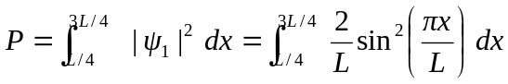
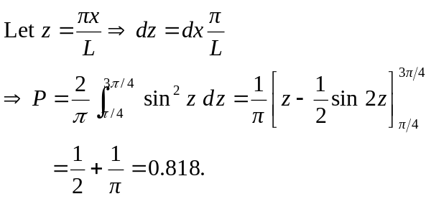
b) 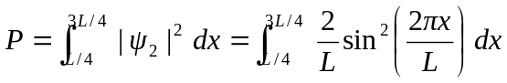
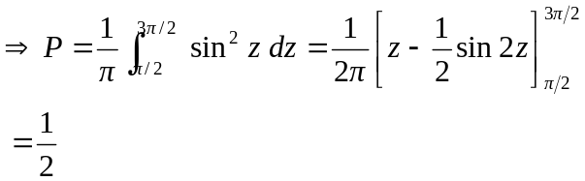
c) This is consistent with Fig. 40.5(b) since more of 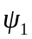 is between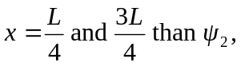
and the proportions appear correct.

